Watch Dog Timer

Version 1.0

SHMT Co., Ltd.

REVISION HISTORY
Version | Detail(굴림/Verdana 10pt bold) | Name | Date
1.0 | Watch Dog Timer Spec. Created | East | 2007-1-28

Technical documents
Copyright © 2007 Shmt Limited. All rights reserved.

Confidentiality Status
This document is NOT OPEN ACCESS. The distribution is restricted to certified company.
This document is CONFIDENTIAL.

Feedback on this document
If you have any comments on this document, please contact your channel to our company.

Shmt Web address
http://www.shmt.com

Contents

1. Function Description 7
1.1. Overview 7
1.1.1. Feature 7
1.1.2. Block Diagram 8
1.2. Operation 8
1.2.1. Clock Prescaler Block 9
1.2.2. Interrupt Generation Block 9
1.2.3. Reset Output Generation 9
1.3. Register Description 10
1.3.1. WDT Registers 10
1.3.2. WDT Control Register 11
1.3.3. WDT Prescale Register 11
1.3.4. WDT Load Register 12
1.3.5. WDT Count Register 12
1.3.6. WDT Interrupt Status Register 13

Figures

Figure 2 Watch Dog Block Diagram 8

Tables
Table 1-1 WDT Registers(Base Address : 1FFF 0000h) 10
Table 1-2 WDT Control Register Description(Offset : 0000 0000h) 11
Table 1-3 WDT Prescale Register Description(Offset : 0000 0004h) 12
Table 1-4 WDT Load Register Description(Offset : 0000 0008h) 12
Table 1-5 WDT Count Register Description(Offset : 0000 000Ch) 12
Table 1-6 WDT Interrupt Status Register Description(Offset : 0000 0010h) 13

Function Description

Overview

Feature

- Support 16 bit Programmable interval down counter.
- Support clock division factor 16,32,64, and 128.
- Support 16 bit prescale counter.
- Support Interrupt Request
- Generation of Reset Output Signal

Block Diagram

Figure 1 Watch Dog Block Diagram
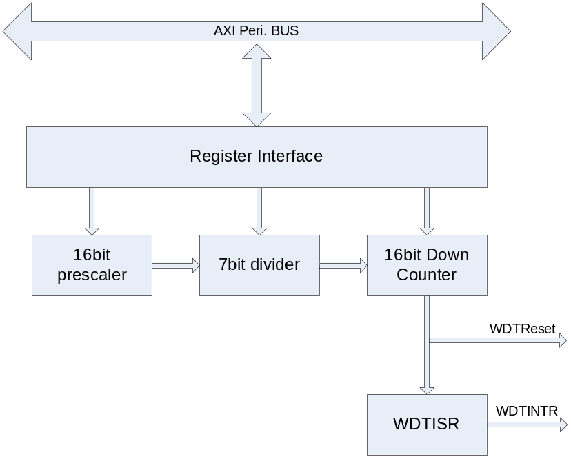

Operation

Chip이 소프트웨어나 다른 환경에 의해 오동작할 경우 전체 동작을 Reset 해주는 역할을 한다.
즉, 카운터 값이 설정된 값에 도달할 경우 Interrupt를 생성하게 되는데, 정상적인 상태에 있는 칩이라면 Interrupt 발생시 마다 카운터 값을 Reload 하여 전체 동작에 Reset를 걸지 않게 할 수 있지만, 반대의 경우라면 칩에 Reset이 걸리게 되어 있다.

Clock Prescaler Block

Interrupt Generation Block

Reset Output Generation

Register Description

WDT Registers

Table 1-1 WDT Registers(Base Address : 1FFF 0000h)
Offset | Name | R/W | Description | Init. value
0000h | WDTCON | RW | WDT Control Register | 0000 0030h
0004h | WDTPSR | RW | WDT Prescale Register | 0000 FFFFh
0008h | WDTLDR | RW | WDT Load Register | 0000 FFFFh
000Ch | WDTCNT | RW | WDT Count Register | 0000 FFFFh
0010h | WDTISR | RW | WDT Interrupt Status Register | 0000 0000h

WDT Control Register

Figure 2-1 WDT Control Register Bits
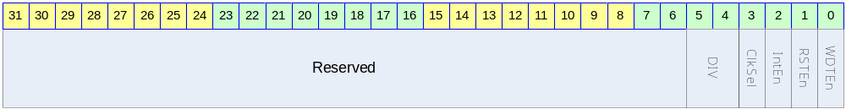

Table 1-2 WDT Control Register Description(Offset : 0000 0000h)
Bits | Name | R/W | Description | Init. value
[31:6] |  |  | Reserved | 0
[5:4] | DIV | RW | 0b00 : 16  0b01 : 32  0b10 : 64  0b11 : 128 | 11b
[3] | ClkSel | RW | 0 : Both Prescale and Divide Clock is used for Counting  1 : Only Prescal Clock is user for Counting | 0
[2] | IntEn | RW | 0 : WDT Interrupt Disable  1 : WDT Interrupt Enable | 0
[1] | RSTEn | RW | 0 : Reset Output Disabled  1 : Reset Output Enabled | 0
[0] | WDTEn | RW | WDT Enable  0 : WDT Disable  1 : WDT Enable | 0

WDT Prescale Register

Figure 2-2 WDT Prescale Register Bits
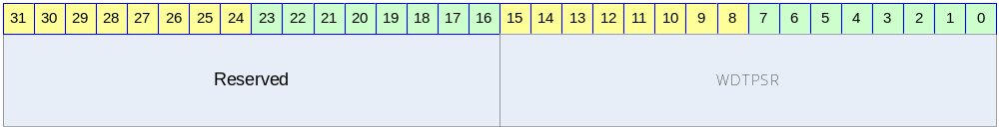

Table 1-3 WDT Prescale Register Description(Offset : 0000 0004h)
Bits | Name | R/W | Description | Init. value
[31:16] |  |  | Reserved | 0
[15:0] | WDTPSR | RW | Prescaler Value | ffffh

WDT Load Register

Figure 2-3 WDT Load Register Bits
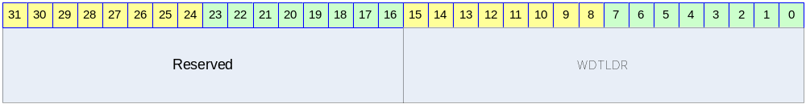

Table 1-4 WDT Load Register Description(Offset : 0000 0008h)
Bits | Name | R/W | Description | Init. value
[31:16] |  |  | Reserved | 0
[15:0] | WDTLDR | RW | Reload Value | ffffh

WDT Count Register

Figure 2-4 WDT Count Register Bits
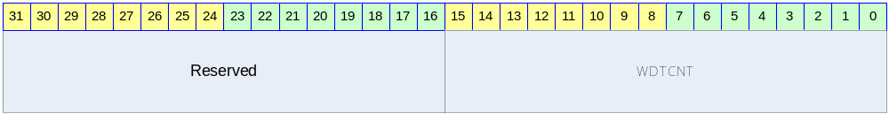

Table 1-5 WDT Count Register Description(Offset : 0000 000Ch)
Bits | Name | R/W | Description | Init. value
[31:16] |  |  | Reserved | 0
[15:0] | WDTCNT | R | Current WDT Count Value | ffffh

WDT Interrupt Status Register

Figure 2-5 WDT Interrupt Status Register Bits
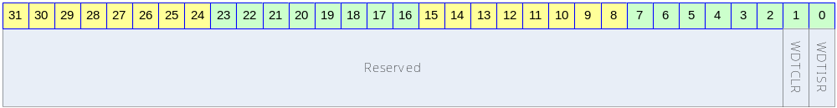

Table 1-6 WDT Interrupt Status Register Description(Offset : 0000 0010h)
Bits | Name | R/W | Description | Init. value
[31:2] |  |  | Reserved | 0
[1] | WDTCLR | W | Write 1, Cleared Interrupt
[0] | WDTISR | R | 0 : Interrupt Is asserted  0 : Interrupt Is not asserted

